Screenshots:
1) AI Agent for Auto mail and reminder system
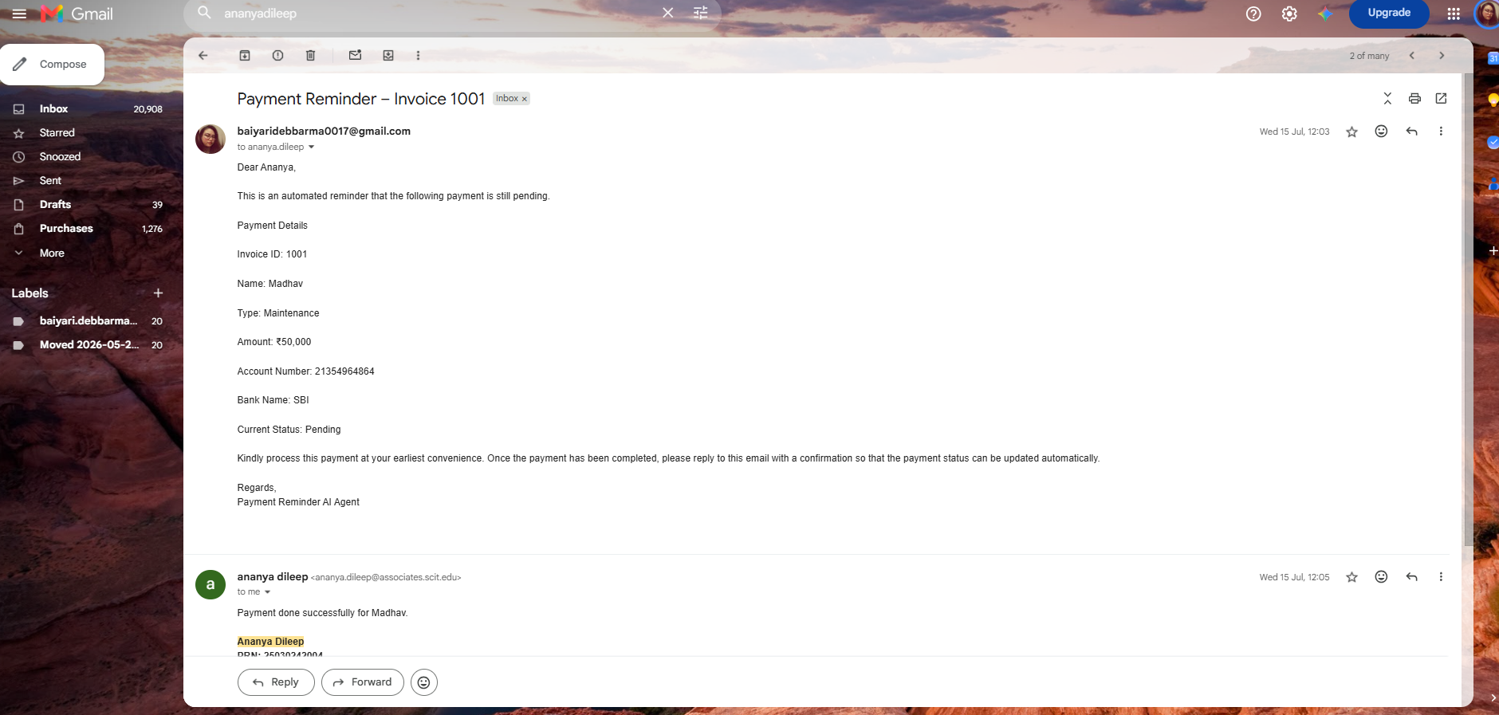
2) MAS_AgenticAI
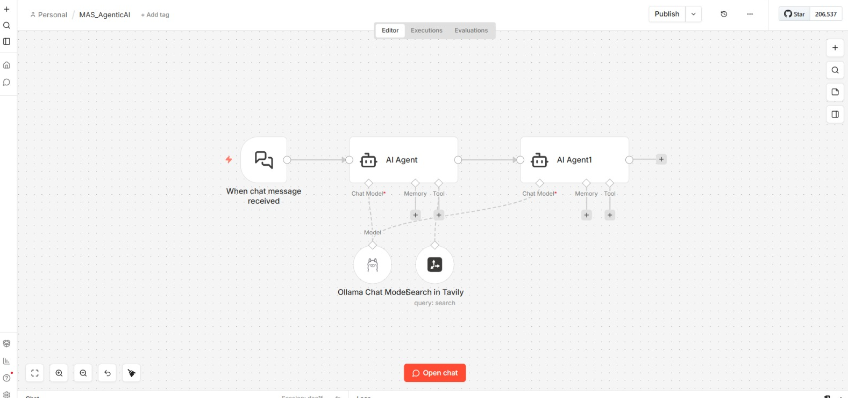
3) Agentic_RAG_Chatbot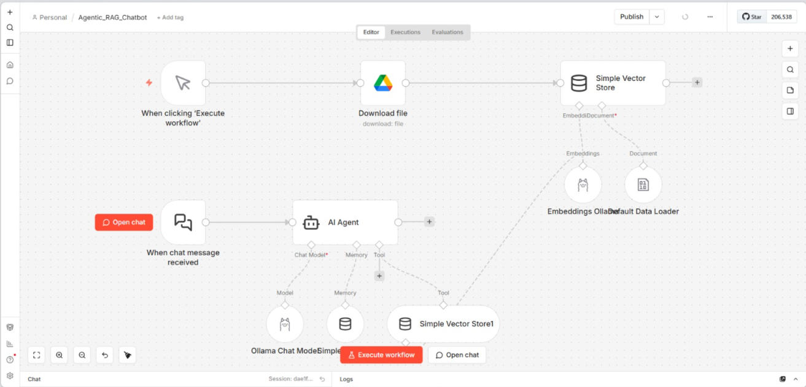
4) Travel Agent Smart Chatbot
